**1a) Course Name: HTML5 - The Language Module Name: Case-insensitivity, Platformindependency, DOCTYPE Declaration, Types of Elements, HTML Elements - Attributes, Metadata Element Include the Metadata element in Homepage.html for providing description as "IEKart's is an online shopping website that sells goods in retail. This company deals with various categories like Electronics, Clothing, Accessories etc.**

<!DOCTYPE HTML>

<head>

<title>ShopTime website</title>

<meta charset="UTF-8">

<meta name="description" content="ShopTime is an online shopping website that sells goods in retail. This company deals with various categories like Electronics, Clothing, Accessories etc">

<meta name="keywords" content="clothing,footwear,shopping">

<meta name="author" content="Myself">

<meta name="viewport" content="width=device-width, initial-scale=1.0">

</Head>

<body bgcolor="cyan">

<h1 align="center"><i>ShopTime<i></h1>

<h2 align="center"><i>One stop for all your needs<i></h2>

<p>Here we are using meta tags like charset,name,author etc.</p>

</body></html>

**OUTPUT:**

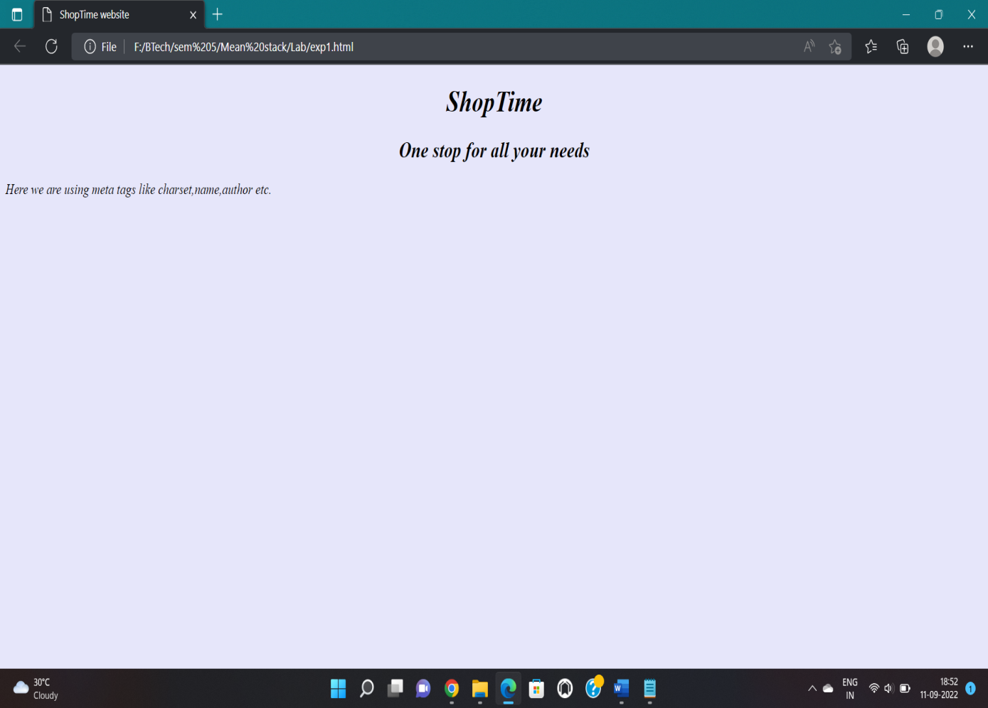

**1b) Course Name: HTML5 - The Language Module Name: Sectioning Elements Enhance the Homepage.html of IEKart's Shopping Application by adding appropriate sectioning elements.**

<!DOCTYPE HTML>

<head>

<title>ShopTime website</title>

</Head>

<body bgcolor="cyan">

<h1 align="center"><i>ShopTime<i></h1>

<h2 align="center"><i>One stop for all your needs<i></h2>

<nav align="center"><h3>

Home || Login || Register || Wishlist || My Orders || Help</h3></nav>

<main>

<section>

<p>Clothing</p>

</section>

<section>

<p>Footwear</p>

</section>

<section>

<p>Electronics</p>

</section>

<section>

<p>Furniture</p>

</section>

<section>

<p>Cosmetics</p>

</section>

</main>

<article>

<h1>Special Offer</h1>

<aside>

<p>Download our app at PlayStore and win exciting prizes.</p></aside>

</article><header>

</body>

<footer>

Copyright @ WayFar, 2020

</footer>

</html>

**OUTPUT:**

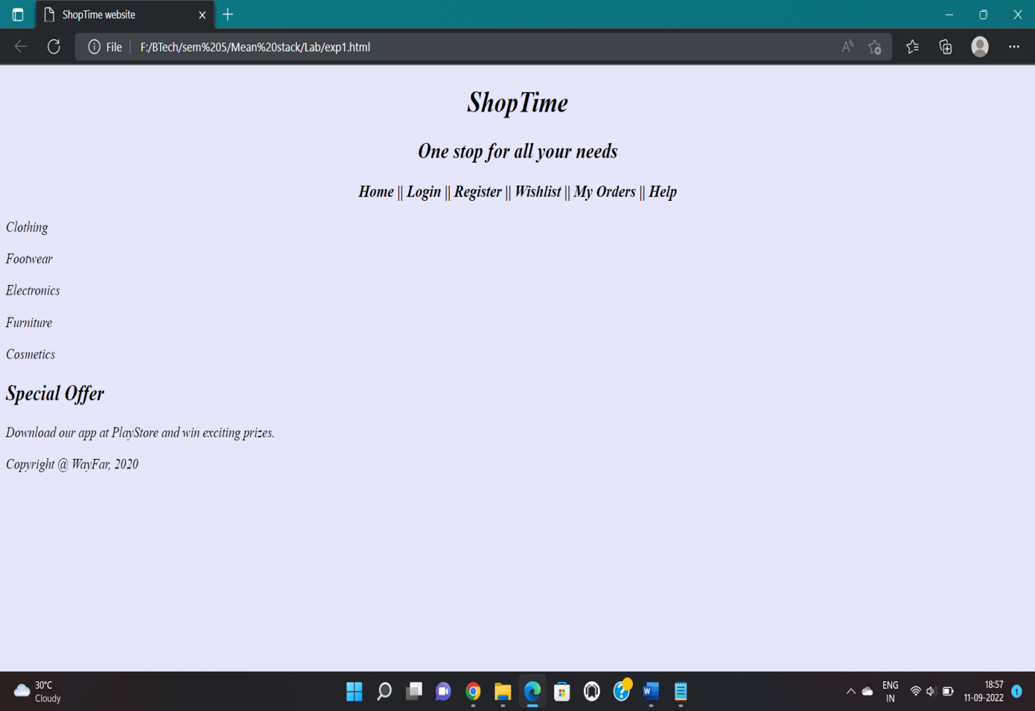

**1c) Course Name: HTML5 - The Language Module Name: Paragraph Element, Division and Span Elements, List Element Make use of appropriate grouping elements such as list items to "About Us" page of IEKart's Shopping Application.**

<!DOCTYPE HTML>

<head>

<title>ShopTime website</title>

</Head>

<body bgcolor="lavender">

<h1 align="center"><i>ShopTime<i></h1>

<h2 align="center"><i>One stop for all your needs<i></h2>

<nav align="center"><h3>

Home || Login || Track Order </h3>

</nav>

<center>

<p><img src="https://www.logomaker.com/wp-content/uploads/2018/01/FLS-Blog-Black-Logos_Hero.jpg" alt="Top shopping brands" width="950" height="300"</p>

</center>

</body>

<footer>

<a href=aboutus.html">About Us</a>

</footer>

</html>

**OUTPUT:**

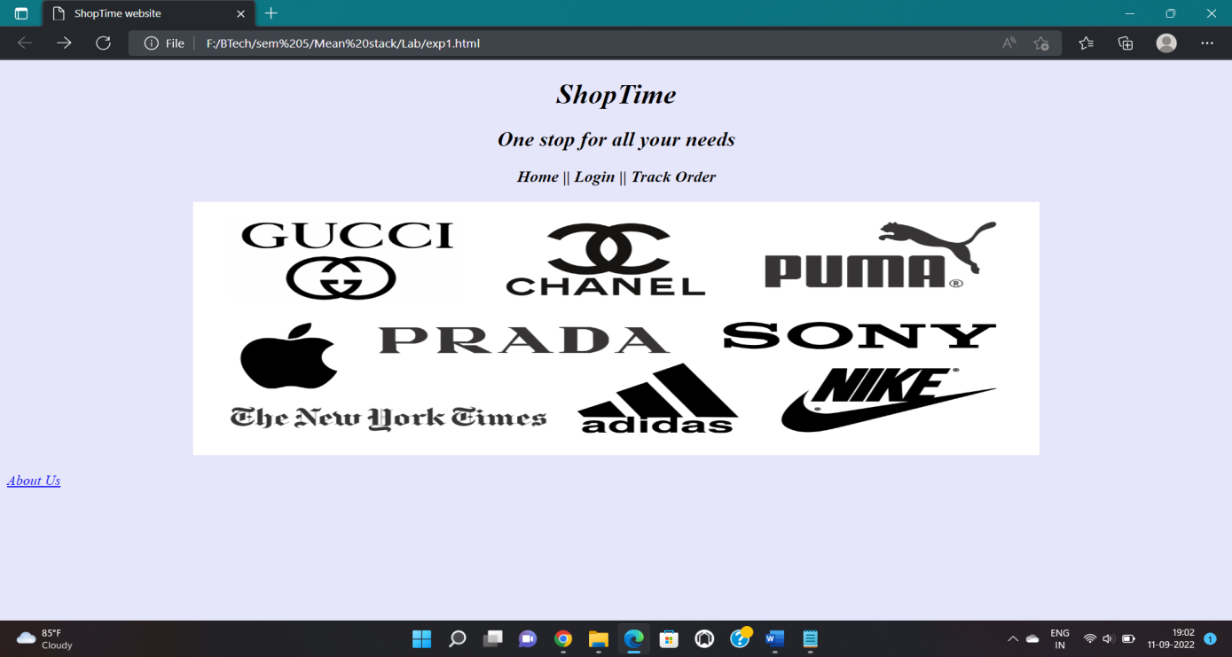

**Aboutus.html**

<!DOCTYPE HTML>

<html>

<head>

<title>ShopTime website</title>

<meta name="viewport" content="width=device-width, initial-scale=1">

</Head>

<body bgcolor="cyan">

<div class="about-section">

<h1>About Us Page</h1>

<p><span style="color:blue;font-weight:bold"><i>ShopTime</i></span> is an indigenous e-commerce website discovering new ways to satisfy customer's needs.</p></div>

<h2>Founders</h2>

<ul>

<li>Jane Doe - Foumder&CEO</li>

<li>John Doe - Art Designer</li>

</ul>

</body>

</html>

**OUTPUT:**

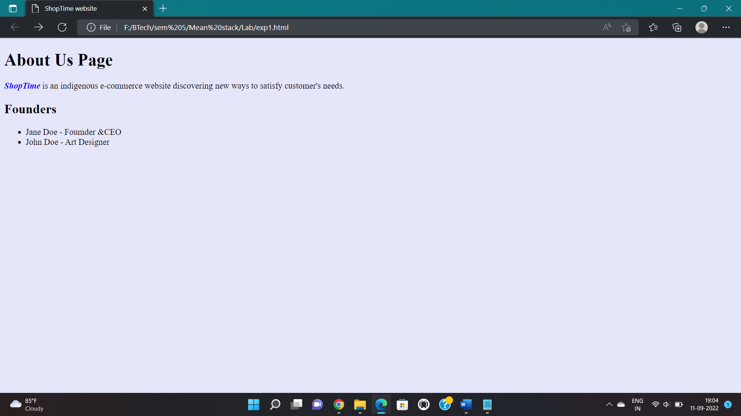

**1d) Course Name: HTML5 - The Language Module Name: Link Element Link "Login", "SignUp" and "Track order" to "Login.html", "SignUp.html" and "Track.html" page respectively. Bookmark each category to its details of IEKart's Shopping application**.

<!DOCTYPE HTML>

<head>

<title>ShopTime website</title>

<meta charset="UTF-8">

<meta name="description" content="ShopTime is an online shopping website that sells goods in retail. This company deals with various categories like Electronics, Clothing, Accessories etc">

<meta name="keywords" content="clothing,footwear,shopping">

<meta name="author" content="Myself">

<meta name="viewport" content="width=device-width, initial-scale=1.0">

</Head>

<body bgcolor="lavender">

<h1 align="center"><i>ShopTime<i></h1>

<h2 align="center"><i>One stop for all your needs<i></h2>

<nav align="center"><h3>

<a href=”home.html”>Home</a> ||<a href=”login.html”> Login</a>

||<a href=”trackorder.html”>Track Order</a></h3>

</nav>

<center>

<p><img src="homeimg.png" alt="Top shopping brands" width="1350" height="300"</p>

</center>

</body>

<footer>

Copyright @ ShopTime, 2020

</footer></html>

**OUTPUT:**

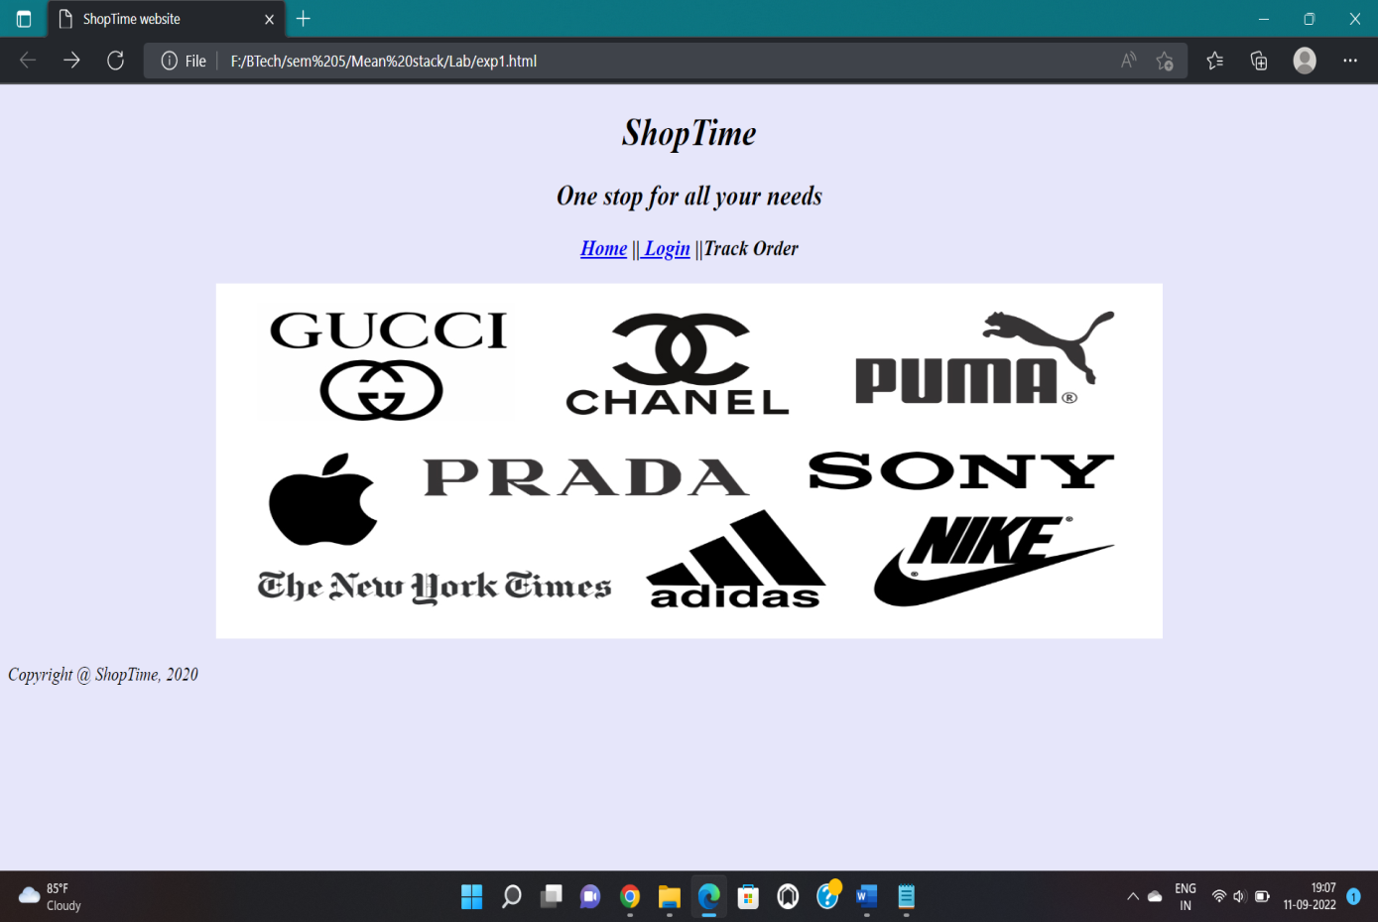

**1e) Course Name: HTML5 - The Language Module Name: Character Entities Add the © symbol in the Home page footer of IEKart's Shopping application**

<!DOCTYPE HTML>

<head>

<title>ShopTime website</title>

<meta charset="UTF-8">

<meta name="description" content="ShopTime is an online shopping website that sells goods in retail. This company deals with various categories like Electronics, Clothing, Accessories etc">

<meta name="keywords" content="clothing,footwear,shopping">

<meta name="author" content="Myself">

<meta name="viewport" content="width=device-width, initial-scale=1.0">

</Head>

<body bgcolor="lavender">

<h1 align="center"><i>ShopTime<i></h1>

<h2 align="center"><i>One stop for all your needs<i></h2>

<nav align="center"><h3>

<a href=”home.html”>Home</a> ||<a href=”login.html”> Login</a> || <a href=”trackorder.html”>Track Order</a></h3>

</nav>

<center>

<p><img src="https://www.logomaker.com/wp-content/uploads/2018/01/FLS-Blog-Black-Logos_Hero.jpg" alt="Top shopping brands" width="950" height="300"</p>

</center>

</body>

<footer>

&copy; ShopTime, 2020

</footer></html>

**OUTPUT:**

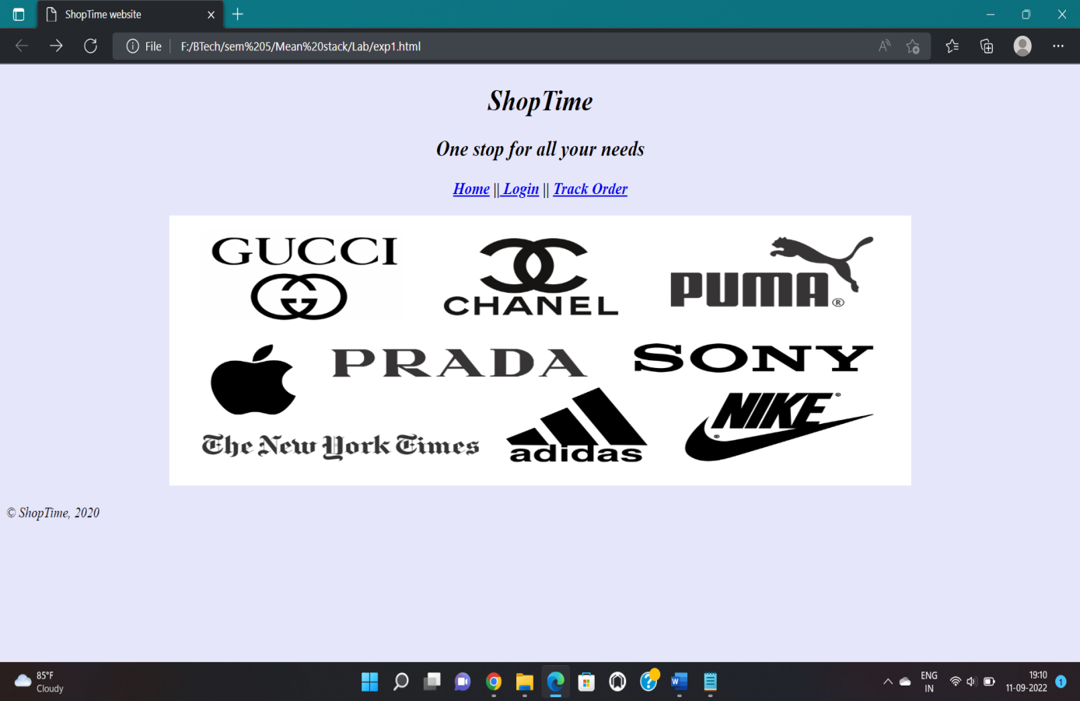

**1f) Course Name: HTML5 - The Language Module Name: HTML5 Global Attributes Add the global attributes such as contenteditable, spellcheck, id etc. to enhance the Signup Page functionality of IEKart's Shopping application.**

<html>

<head><title>ShopTime</title></head>

<body bgcolor="cyan">

<h1 align="center"><i>ShopTime</i></h1>

<form>

<center>

<h3>Sign up</h3>

<table>

<tr><td>Name :</td><td><input type="text"></td></tr>

<tr><td>Email:</td><td><input type="email" contenteditable="true" spellcheck="true" ></td></tr>

<tr><td>User Name :</td><td><input type="text"></td></tr>

<tr><td>Date of birth:</td><td><input type="date"></td></tr>

<tr><td>Password :</td><td><input type="password"></td></tr>

<tr><td>Confirm Password :</td><td><input type="password"></td></tr>

<tr><td></td><tdalign="center"><input type="submit"></td></tr>

</center>

</form>

</body></html>

**OUTPUT:**

